**Node.js**

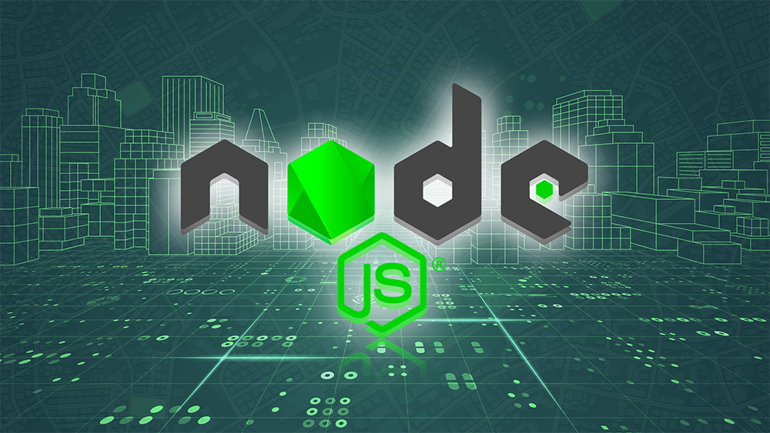

**Node.js**

Node.js is a popular open-source runtime environment that allows developers to build scalable and efficient server-side applications using JavaScript. It has gained significant popularity due to its event-driven architecture and non-blocking I/O capabilities, which make it an ideal tool for building real-time applications.

One of the key features of Node.js is its ability to handle multiple concurrent connections, making it highly suitable for building applications that require high-performance and responsiveness. Node.js is also highly modular and can be easily extended with third-party libraries, which helps developers to build complex applications quickly.

**FEATURES:**

Some of the advanced features of Node.js that are worth highlighting include:

**Asynchronous programming**: Node.js is built on the principle of asynchronous programming, which means that it can handle multiple requests simultaneously without blocking the main thread. This makes it highly efficient and responsive, especially for applications that require real-time data processing.

**Event-driven architecture**: Node.js is designed around an event-driven architecture, where actions are triggered by events rather than traditional control flow statements. This makes it highly flexible and adaptable, allowing developers to build complex applications with ease.

**Package management**: Node.js has a powerful package manager called npm, which allows developers to easily install and manage third-party libraries and dependencies.

**Scalability**: Node.js is highly scalable and can handle large amounts of traffic without requiring a lot of resources. This makes it an ideal choice for building applications that need to handle high volumes of traffic.

**Cross-platform compatibility**: Node.js is cross-platform compatible, which means that it can run on a wide range of operating systems including Windows, macOS, and Linux.

Streaming data: Node.js can stream large amounts of data in real-time, making it ideal for applications that require real-time data processing such as video streaming or chat applications.

**Non-blocking I/O**: Node.js has a non-blocking I/O model, which means that it can handle multiple I/O operations simultaneously without blocking the main thread. This makes it highly efficient and responsive, especially for applications that require real-time data processing.

**Built-in modules**: Node.js has a number of built-in modules that simplify common programming tasks, such as file system operations, network connectivity, and cryptography.

**Single-threaded event loop**: Node.js uses a single-threaded event loop architecture, which allows it to handle multiple requests simultaneously without creating new threads or processes. This makes it highly efficient and reduces resource usage.

**Debugger support**: Node.js has built-in support for debugging, which allows developers to identify and fix issues quickly.

To evaluate the usage and advanced features of Node.js, it is important to consider real-world use cases where it has been successfully deployed.

**APPLICATIONS:**

Some examples of applications built using Node.js include:

**LinkedIn**: LinkedIn uses Node.js to handle real-time data updates, notifications, and messaging.

**Uber:** Uber uses Node.js for their real-time market data platform, which is responsible for matching drivers with passengers in real-time.

**Netflix**: Netflix uses Node.js for their web interface, which is responsible for serving millions of requests per second.

**PayPal**: PayPal uses Node.js for their developer portal, which is responsible for serving up-to-date documentation and resources to developers.

In conclusion, Node.js is a powerful and versatile tool that offers a wide range of advanced features for building scalable and efficient server-side applications. Its asynchronous programming model, event-driven architecture, package management, scalability, and cross-platform compatibility make it an ideal choice for building real-time applications that require high-performance and responsiveness. By evaluating real-world use cases of Node.js, developers can gain a deeper understanding of its capabilities and how it can be used to build complex applications quickly and efficiently.

**References:**

1. Node.js official website: <https://nodejs.org/en/>
2. "Asynchronous programming in Node.js" by Joyent: <https://www.joyent.com/node-js/production/design/assuring-performance-node-js>
3. "Understanding the Node.js event loop" by RisingStack: <https://blog.risingstack.com/node-js-at-scale-understanding-node-js-event-loop/>
4. "Introduction to npm" by npm: <https://docs.npmjs.com/about-npm/>
5. "Scaling your Node.js applications" by IBM Developer: <https://developer.ibm.com/articles/5-things-to-know-nodejs-scale/>
6. "Node.js at Netflix" by Netflix: <https://medium.com/@nodejs/node-js-at-netflix-a88ac17e9072>
7. "Node.js at Uber" by Uber: <https://eng.uber.com/node-js-at-uber/>
8. "Node.js at LinkedIn" by LinkedIn: <https://engineering.linkedin.com/blog/2016/02/nodejs-at-linkedin>
9. "Node.js application examples" by Node.js Foundation: <https://nodejs.org/en/about/examples/>
10. "Stream Handbook" by substack: <https://github.com/substack/stream-handbook>